10
Usability Heuristics:
FIFA 22 (PS5)

XiangLong Ronaldo Lin (45791439)

DECO2500

Introduction

FIFA is the representative game series under EA Sports, the annual new release will certainly trigger a wide range of hot discussion about the design result. At present, FIFA 23 has been officially released, which will be renamed EA Sports FC in the following year. In addition, FIFA has been recognized by Guinness World Records as the best-selling sports video game series until now. [1]

This essay is based on Nielsen's 10 Usability Heuristics for User Interface Design to determine FIFA 22, which is still relatively popular console game in PlayStation 5 (PS5), and evaluate. Then FIFA 22 is highly concluded and the constructive suggestions are given. Hopefully, both FIFA 23 and the future EA Sports FC series will create a qualitative breakthrough on the heuristics to better bring the user effective performance improvements on human-computer interaction.
- FIFA 22
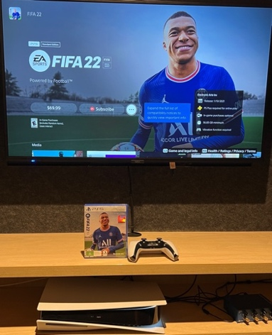
- The PS5 Console
- The PS5 Controller
Figure 1. FIFA 22 in PS5

Critical Evaluation

- Visibility of System Status

The heuristic is the user interface informs the current state by timely and appropriate feedback. FIFA 22 has an excellent loading page design, the system both conveys the game state and incorporates the unique elements. First in the entry page, visually, this system appears the iconic EA and FIFA 22 logos, denoting that this game has been started. In the waiting process, "Please wait" is displayed to indicate that this system is running normally to avoid the misunderstanding as a system issue to cause the data loss or the system damage due to forced restart. With the animation contained the square flag symbolizing the beginning of the race, this system means that the loading is compeleted in the flag language [2]. Combined with the entrance of the star, this system vividly expresses that the main page has been reached and the control is now handed over to the controller. Besides, auditorily, the system still plays the symbolic dub of "EA Sports, it's in the game." to strongly inform that the game interface is entered.

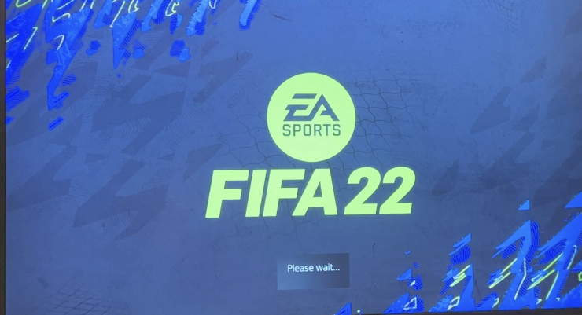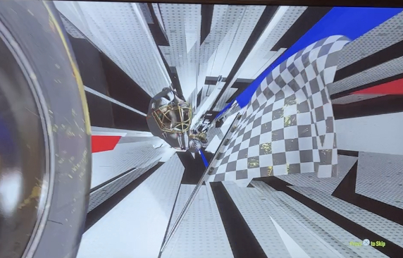
- The Square Flag
- “Please wait”
- The EA and FIFA logos
Figure 2. The EA and FIFA logos & Please Wait Figure 3. The Square Flag Animation
- The Soccer Star
- "EA Sports, it's in the game."
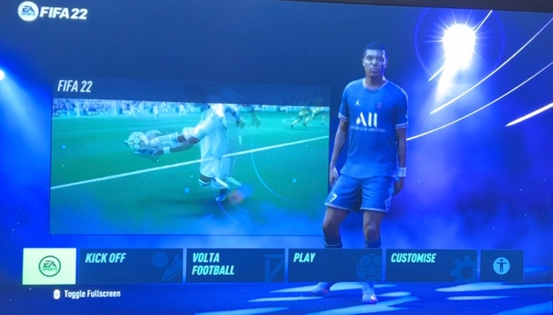
Figure 4. The Entrance of the Star Figure 5. EA Sports, It's in the Game

- Match Between System and the Real World

This heuristic is the user interface applying the real-world scenario. FIFA 22 has been able to more appropriately reproduce the real life world. Before entering a game or by pausing an ongoing game, the language can be changed. This system will also match the language with the region selection in the account. Moreover, the formation is set by the up, down, left, and right of the joystick correspond the position of the player to move forward, back, to the side, and to the middle. Furthermore, Hicks Law notes that the fewer option can effectively reduce the selection difficulty. [3] FIFA 22 has developed several common formations to be quickly selected, performing the cognitive science to reduce the mental effort to ensure the game fluency and the user experience.

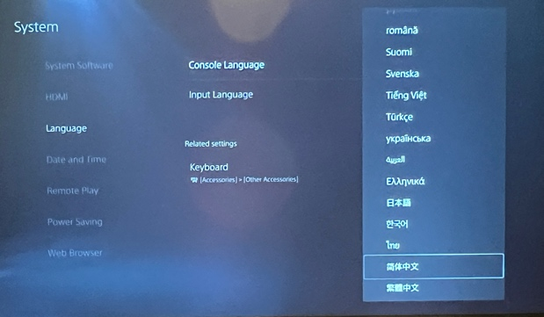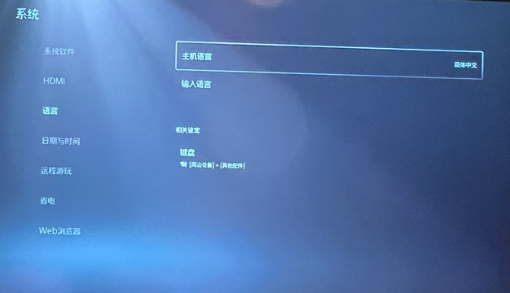
Figure 6. The Language Setting (English) Figure 7. The Language Setting (Chinese)

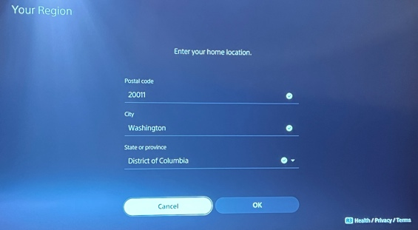
Figure 8. The Region Selection
- Forward
- To the Side
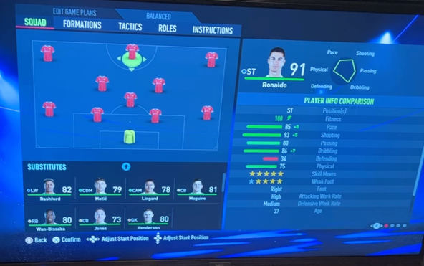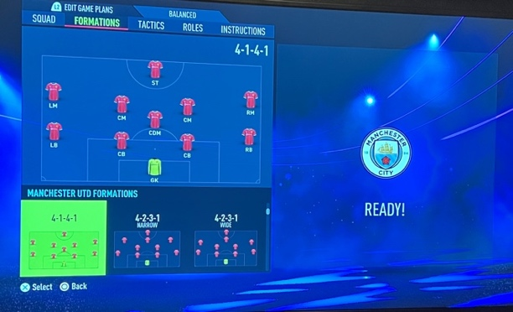
- To the Middle
- Back
Figure 9. The Player Position Figure 10. The Formation Selection

- User Control and Freedom

This heuristic targets the revocation, return, and exit instructions for the incorrect selection. FIFA 22 has established a complete operation set on the controller, the X key and the Circle key are defined as the confirmation and the cancellation respectively. Meanwhile, the PS icon button can be long pressed to return directly to the home page.

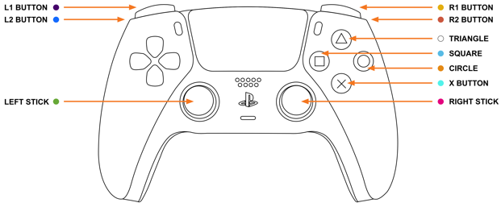 [4]
- The Circle key
- The X key
- The PS icon button
Figure 11. The PS5 Controller

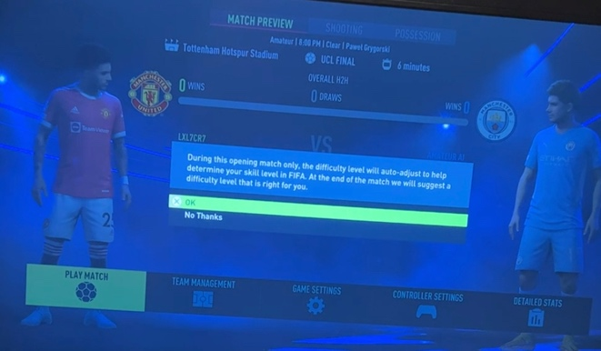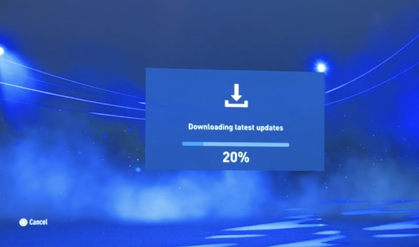
Figure 12. The Confirmation Figure 13. The Cancellation
- Consistency and Standards

This heuristic aims at the unified cognition for the load. The FIFA series all adopt a consistent layout to effectively reduce the time to switch and adapt between each version. Unilaterally, FIFA 22 is built in the dark card-based metaphor, the information is classified to be more easily followed. Multilaterally, FIFA 22 maintains the same representation on the similar content, including the player mode, the manager mode, and the team mode,to effectively increase the comfort.
- The Dark Card-based Metaphor
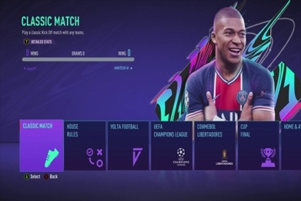 [5] 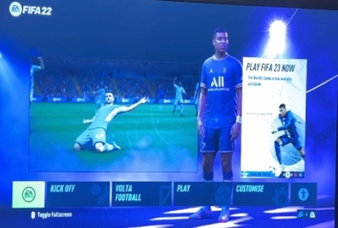 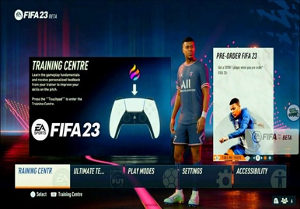 [6]
Figure 14. FIFA 21 Interface Figure 15. FIFA 22 Interface Figure 16. FIFA 23 Interface
- The Square-based Styles
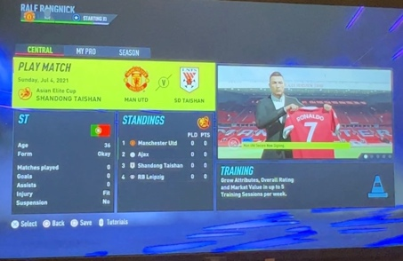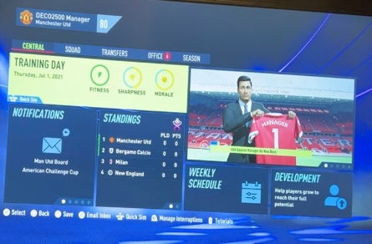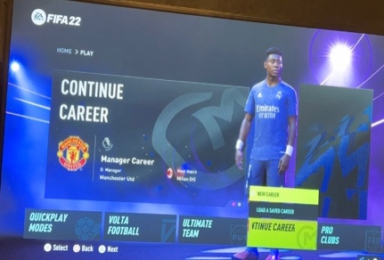
Figure 17. The Player Mode Figure 18. The Manager Mode Figure 19. The Team Mode

- Error Prevention

This heuristic establishes the mechanism to prevent the error and replaces the reminder to reduce the loss caused by the misoperation. FIFA 22 had added the dual protections to ensure the security of the data. On the user side, such as deleting the archive, this system will generate a confirmation alarm pop-up window, and then the deletion instruction will be executed only after the second confirmation. On the system side, under the mode where archiving is required, for example, exiting the game, the system will also create a save alarm pop-up window. After the “Autosave & Quit” selection, this system will automatically establish a new archive.

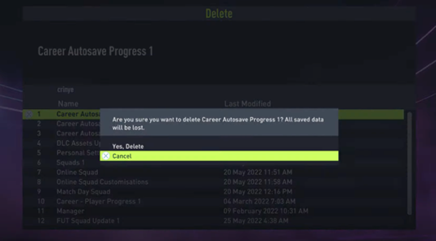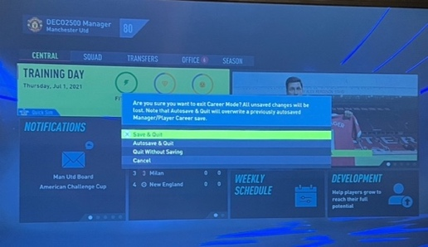
Figure 20. The Second Confirmation Figure 21. The “Autosave & Quit” Selection
- Recognition Rather than Recall

This heuristic sets the system that works for the memory, largely preventing the occurrence of the cognitive overload. FIFA 22 is very humanized in both the short-term and the long-term data records. After the unexpected exit to the ongoing game and returns to the game interface, this system will immediately prompt the ongoing game, and request the instruction to return or reopen a new game, which is an ideal real-time handover. Futhermore, when the user chooses the archive to be automatically saved, this system will name the archive in terms of the storage time point, which will facilitate the user to view and retrieve.

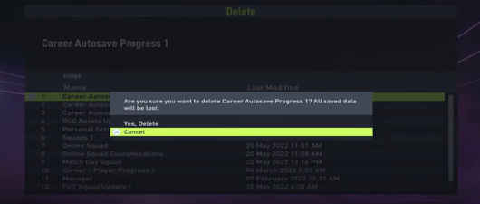
Figure 22. The Storage Time Point

- Flexibility and Efficiency of Use

This heuristic requires the interface to customize the optimization depending to the proficiency. With the greater function diversity, FIFA 22 has formed a targeted operation mode in simplifying the process. The user can use the controller button to skip the certain appearance and go directly into the next process by pressing and holding. The animation can be skipped in advance by pressing or holding the X key in the loading interface and the entry interface, and the training chapter can be finished ahead by pressing the Options button in the pre-game training interface.

 [7]
- Press the Options Button
- Press the X key
- Hold the X key
Figure 23. The PS5 Controller

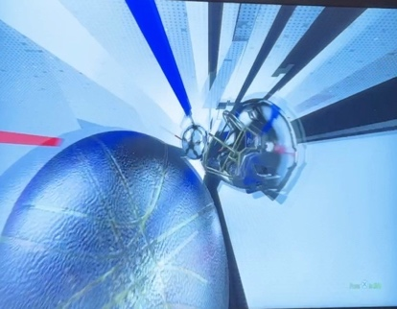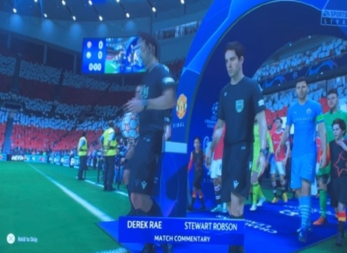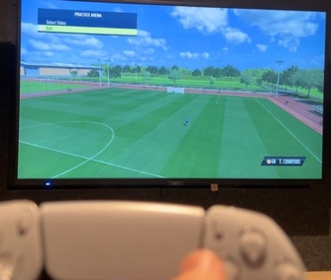
Figure 24. The Loading Figure 25. The Entry Figure 26. The Pre-game Training
- Aesthetic and Minimalist Design

This heuristic devotes particular care to the trade-off between the information expression and the screen embodiment, which are mutually helpful but also exclusive. FIFA 22 achieves an outstanding coordination, fully responding to the different need in the different scenarios. The system greatly reduces the frequency of the text in the game screen, conversely, the number of the pattern is widely reduced in terms of the user selection. In the process of controlling the player, the game interface only retains the team name abbreviation, the current score, and the affiliation mode in the upper left corner, the game logo in the upper right corner, and the number and the name of the local player and the opposing player below. For example, the user can adjust the formation attack intensity by pressing the R1 button shortcut, and the dialogue box will only occupy a little space on the local player box.
- The Team Name Abbreviation
- The Number and the Name of The Local Player and the Opposing player
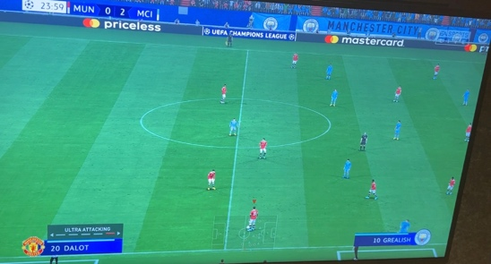
- The Dialogue Box (Formation Attack Intensity)
- The Game Logo
- The Affiliation Mode
- The Current Score
Figure 27. The Game Interface

- Help Users Recognize, Diagnose, and Recover from Errors

This heuristic provides the narrative of the error and the suggested solutions in the user language. FIFA 22 can do an great job of responding to the error with ensuring the consistency. The user interface usually gives a retry option and a cancel option after briefly and accurately describing the error, and the other specific option will be covered according to the different error. For instance, after the archive fails, the third solution “Continue without saving” will be also delivered.

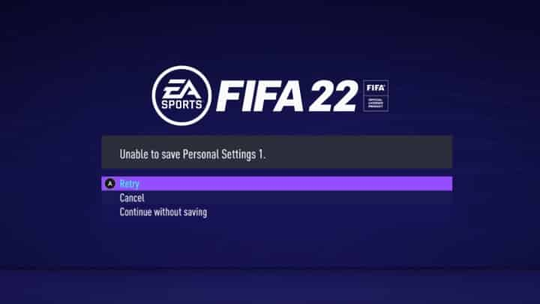
Figure 28. The Retry and Cancel & The “Continue Without Saving” Solutions

- Help and Documentation

This heuristic furnishes the explanation program to assist and possess the search function and the focus steps. The tutorial and document are easy to be found in FIFA 22 under the user tendency. About the game tutorial, supposed in the control setting page, the user interface concentrates the controller guidance for the comparison and learning. For the game document, assumed in the User's Guide, Health & Safety, and Other Information page, the user interface also categorizes the required documents for the consultation.

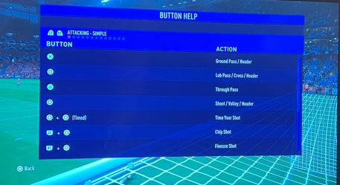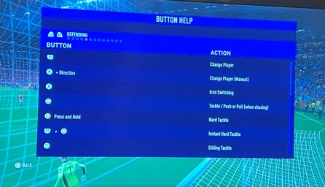
Figure 29. The Game Tutorial (Attacking) Figure 30. The Game Tutorial (Defending)

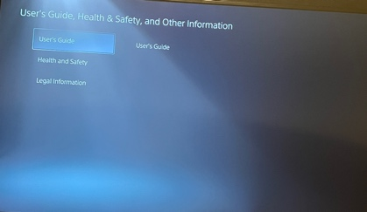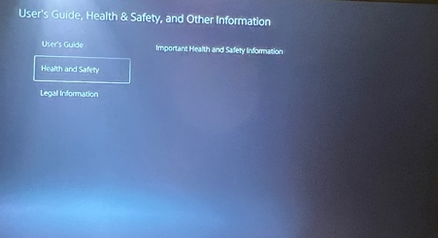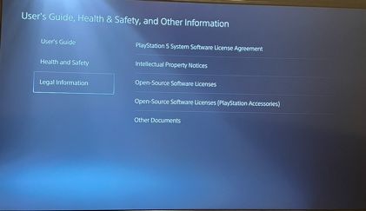
Figure 31. The Game Document (User's Guide) Figure 32. The Game Document (Health & Safety) Figure 33. The Game Document (Other Information page)

Conclusions

The heuristics promote a more comprehensive inspection [8], it is worthy of the affirmation and commendation that FIFA 22 is competent, which naturally explains why FIFA can become the most competitive 3A masterpiece [9]. The heuristics are not independent of each other but tend to influence and achieve each other. FIFA 22 well combines these heuristics but does not limit to these heuristics. With the actual soccer sports world as the background, and the smooth experience of the user on PS5 as the core purpose, FIFA 22 is designed as the most immersive console game.

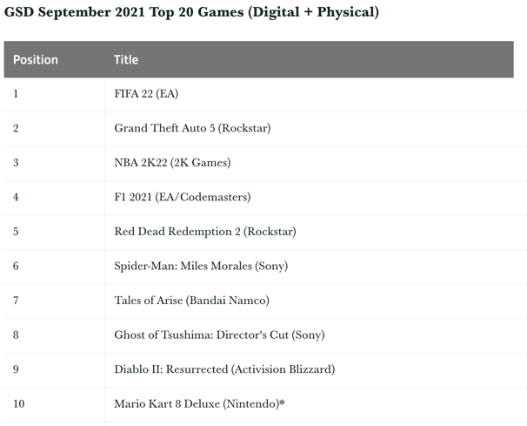 [10]
Figure 34. The Top 10 Games inside The Top 20 Games
Since more different innovations in the design technology, these heuristics may not fully cover the current need [11], and more heuristics are explored and integrated into the modern design. The design is enough to make FIFA 22 stand out [12], but the trailer still reveals that FIFA 23 will have more modifications. However, there is no doubt that the pragmatism-centered design standard left by these heuristics are still valuable in the contemporary design, and FIFA 23 and the future EA Sports FC series are expected to have more enhancement.

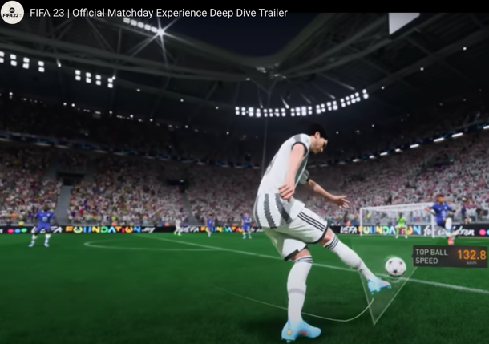 [13]
The New 3D Design
Figure 35. The FIFA 23 Trailer

Areas of Improvement

The flawless interface must be designed more than once [14], and there is no entirely comprehensive heuristics [15]. This demonstrates that the user interface and the heuristics will always have the room to meliorate, and this section focuses on the improvements in Recognition Rather than Recall, Flexibility and Efficiency of Use, and Help and Documentation.

- The multiple trials have discovered that for different archives with the same name, or the cloud archive is full loaded, this system will directly overwrite or delete the old archive. This flaw is very likely to cause the user to spend much more effort and time renaming to prevent the data loss but affect the final game experience. FIFA may be able to change the archive grouping beyond the time point by the system automatic recognition rather than the user manual align input.
- Name
- Kind
- Date Last Opened
- Date Added
- Date Modified
- Date Created
- Size
- …
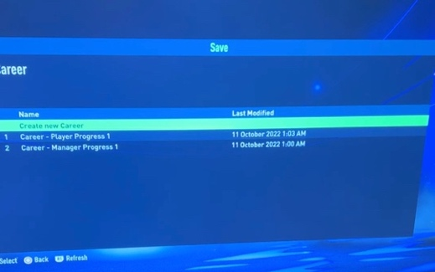
Figure 36. The Archive Override and Deletion

- Some of the keys in FIFA 22 were confirmed to be fixed and unchangeable. This means that the user cannot personalize the key, and the user interface is not flexible and humanized enough on this point. The allowance to the key adjustment to the mapping and function can friendly improve the availability factor.
- Key Mapping

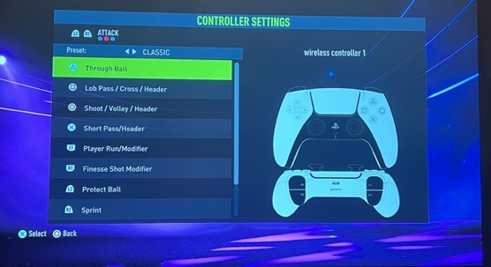
- Key Function

- …

Figure 37. The Key Adjustment

- No explanation interface was found with a search box after the long search. This shows that it could be difficult for the user to quickly and accurately navigate to the related document, greatly reducing the search efficiency of the user interface. The addition of the search engine for the tutorial and the document pages can further help the user.
The Search Engine
Search Here

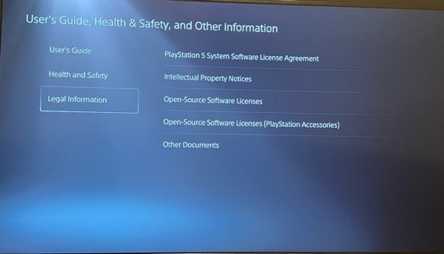
Figure 38. The Search Engine

References (IEEE)

[1]"Best-selling Sports Videogame Series", Guinness World Records, 2022. [Online]. Available: https://www.guinnessworldrecords.com/world-records/92071-best-selling-sports-videogame-series. [Accessed: 13- Oct- 2022].

[2]"Racing Flags F1", Sportskeeda, 2022. [Online]. Available: https://www.sportskeeda.com/f1/racing-flags-f1. [Accessed: 13- Oct- 2022].

[3]N. Baghaei, Human-Computer Interaction (HCI) DECO2500/7250 Week 6. Brisbane: The University of Queensland, 2022, p. 34.

[4]Mega Modz, The PS5 Controller. 2022.

[5]M. Butler, FIFA 21 Interface. 2022.

[6]E. Gamer, FIFA 23 Interface. 2022.

[7]Mega Modz, The PS5 Controller. 2022.

[8]M. Langmajer, "10 Usability Heuristics Every Designer Should Know", Medium, 2019. [Online]. Available: https://uxdesign.cc/10-usability-heuristics-every-designer-should-know-129b9779ac53. [Accessed: 13- Oct- 2s022].

[9]M. Ivanov, H. Wittenzellner and M. Wardaszko, Video Game Monetization Mechanisms in Triple A (AAA) Video Games. Springer, 2021, p. 394.

[10]C. Dring, GSD September 2021 Top 20 Games (Digital + Physical). 2021.

[11]E. Gonzalez-Holland, D. Whitmer, L. Moralez and M. Mouloua, "Examination of the Use of Nielsen’s 10 Usability Heuristics & Outlooks for the Future", ResearchGate, 2017. [Online]. Available: http://Emily Gonzalez-HollandDaphne WhitmerDaphne WhitmerLarry MoralezMustapha MoulouaMustapha Mouloua. [Accessed: 13- Oct- 2022].

[12]R. Murphy, "FIFA 22 review: The most fun FIFA in years is more realistic, but still has its flaws", Goal, 2021. [Online]. Available: https://www.goal.com/en-au/news/fifa-22-review-most-fun-fifa-years-more-realistic-still-has-flaws/8t0fiitfuz2o12x1blradgvnn. [Accessed: 13- Oct- 2022].

[13]EA SPORTS FIFA, FIFA 23 | Official Matchday Experience Deep Dive Trailer. 2022.

[14]J. Nielsen, "Iterative user-interface design", Computer, vol. 26, no. 11, pp. 32-41, 1993. Available: https://ieeexplore.ieee.org/abstract/document/241424. [Accessed 13 October 2022].

[15]C. Lewis and J. Rieman, TASK-CENTERED USER INTERFACE DESIGN, 1st ed. 1993, p. 8.

